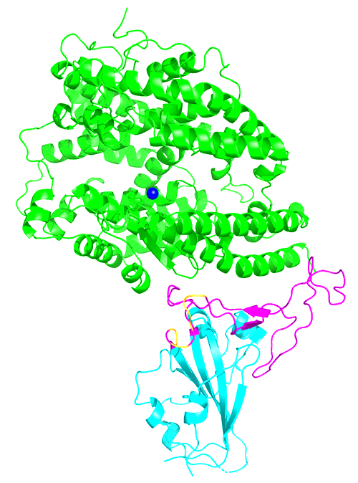**Flow Chart**

**Aim of the Experiment:**

Express **receptor-binding domain (RBD)** in stably transformed rice cell for developing country applications. Comparing level of the RBD protein production of different tissue and different plants individual.

Production of the SARS‐CoV‐2 Receptor

‐binding Domain in stably Transformed

Rice Plants for Developing Country

Applications, Saba-Mayoral A. 2023.

**Protocols and Explanation Notes**

The sequence of the RBD can be found in NCBI by Gene ID *1489668*, while its full name is ***S spike glycoprotein***. After getting the RBD gene sequence send it to the company to synthesize the fragment

Although we can directly use the original DNA sequence to synthesize, because RBD is spike of SARS-COV-2, its expression location is usually mammalian cells. If we use protein sequences from the database and use the ***reverse translate*** algorithm to obtain the DNA that are more suitable for synthesising in monocotyledonous plant cells, it will match the codon of the host as we use rice for gene expression.

In the process of designing RBD sequence, we insert two different types of promoters before the RBD sequence, which are ubiquitin (Ubi-1) promoter and endosperm-specific barley D-hordein (Hord) promoter. Which means construct two different type of target RBD gene: ***pUbi-RBD*** and ***p-Hord RBD***.

|  |  |  |
| --- | --- | --- |
|  | Ubi promoter | Hord promoter |
| Type | House-keeping gene promoter | Luxury gene promoter  (Expressed in send) |
| Express in | All tissue: Callus, Roots, Flag Leaf, Leaf, Seed coat, Seed | Only in  Callus and Seed |

***Chart 1.*** *Two promoters used in the experiment*

***Tumour inducing plasmid (TiP)*** of ***Agrobacterium***is chosen as the vector. There are also some other method and medium such as CaMV and PEG which are wildly use in plant genetic transformation.

The Ti plasmid includes the T-DNA region that can integrate the target gene, the Vir region that encodes transfer related proteins, the Con region,and the Ori region that regulates plasmid self-replication. The changes in the ***T-DNA region*** during the modification process are as followed.

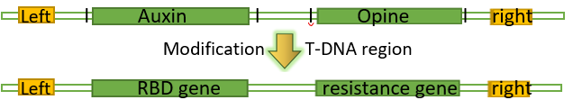

**Flow chart**

**Step 1:** Construction and Incubation of the Vector Contains RBD Gene

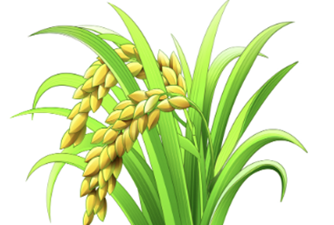

**Synthesize the DNA**

Send the RBD sequence with the restriction site suitable for vector and Ubi or Hord promoter to the company.

**Get the sequence of RBD**

Search the sequence of the RBD in the NCBI database and reverse translate it to the DNA sequence.

s

**Modification of TiP**

Using restriction endo-nucleases to modify TiP. Insert the synthesized RBD gene and antibiotic resistance fragment into plasmids by DNA ligase.

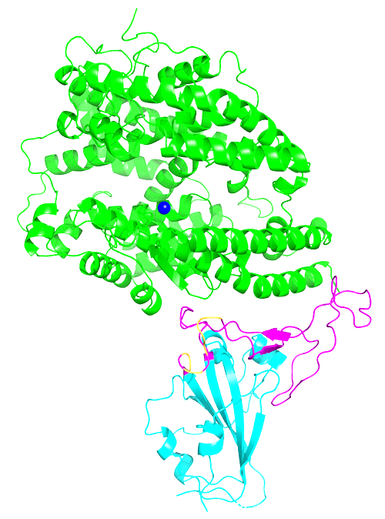

**Obtaining Purified Protein**

Process the mature tissues of different T0 plants to obtain protein solutions. Purify RBD using human ACE2 protein **specific affinity chromatography.**

|  |  |  |
| --- | --- | --- |
| Plant line | Lines 9, 19, 16 | Line 8, 12, 24 |
| Promotor | p-Ubi | p-Hord |
| Target Tissue | All tissue: Callus, Roots, Flag Leaf, Leaf, Seed coat, Seed* | Callus  Seed* |

***Chart 2.*** *All the tissue that should be tested. Seed* here is T1 seed.*

***Protocol of Protein Purification*** 1.Crush the tissue into suspension, add protease inhibitor buffer, using filtration, centrifugation and solvent dissolution to remove magazines. 2. Loading protein solution into affinity chromatography matrix containing human ACE2. The RBD protein will bind to it. 3. Wash off non-specific impurities by wash buffer solution. 4. Once the wash buffer has completely entered the resin bed, add elution buffer and begin collecting fractions.

Protein should be extracted three times (biological replicates), and obtain 3 samples for each tissue from every lines.

The final number of samples should be: 3*(3*6+3*2) =72 tubes.

**Step 2:** Cultivation of Transformed Rice Strains

**Selection & Regeneration**

Select the transformed callus survive on the selective medium and remove after regeneration.

**Incubation of the Vector**

Isolate mature embryos from rice seeds. Deliver construct into callus via Agrobacterium-mediated transformation.

**Cultivate Positive Plants to Maturity**

Monitor the protein expression in callus via western blot. 3 RBD positive plants were cultured for maturity.

***Protocol of Cultivation*** 1. Take some fresh callus tissue for ***Western blotting*** for RBD. 2. Transfer rice callus that can detect RBD to MS medium or B5 liquid. 3. Wait for the callus to form organ primordia and embryoids. 4. Reduce the concentration of cytokinins and increase the auxin. 5. Transplanting to experimental fields after roots formation. 6. Take tissue from 6 mature plants for ***PCR*** to detect gene of interest.

These two methods of Western blotting and PCR help us select RBD positive plants.

Here, we use ***ACE2*** as a capture reagent to purify RBD proteins. Several bands can be designed, including ***65 callus bands*** of the same fresh weight, ***RBD protein positive control bands (selective)***, and ***maker bands***. RBD weight 25kDa so the positive band should appear near the 25kDa of broad rage maker on the electrophoresis gel.

PCR is a sequencing method that can determine whether the plant has transferred to the RBD protein gene without mutation.

Regenerated **14** T0 transgenic plant with ***pUbi-RBD***, lines ***8***, ***12***, ***14*** taken to maturity.

Recovered **34** transgenic callus transformed with ***pHord-RBD***

Recovered **31** transgenic callus transformed with ***pUbi-RBD***

Regenerated **15** T0 transgenic plant with ***pUbi-RBD***, lines ***9***, ***19***, ***26*** taken to maturity.

***Protocol of Incubation*** 1. Isolating the separated embryos to the tube for microcentrifuge. 2. Add Agrobacterium solution and invert the tubes repeatedly. 3. Incubate at room temperature. 4. pour the Agrobacterium suspension with the embryos. 5. Transfer embryos to co-cultivation, incubated in the dark.

**Step 3:** Measuring RBD expression level in plant cells by ELISA

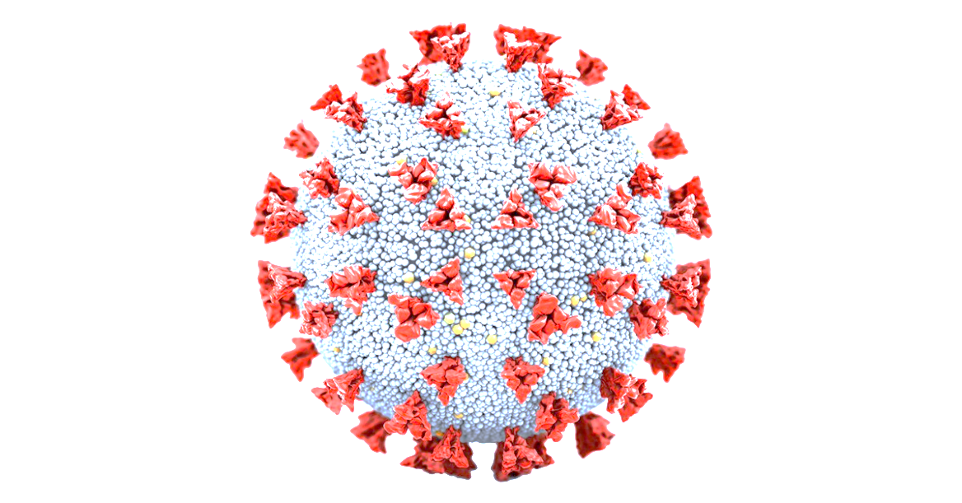

**Result and Conclusion**

1. Lines 9 and 19 represent higher RBD yield among all. Lines 19 seeds produce highest level of RBD with approximately 5.31 ± 0.50 μg/g(fresh weight) beside callus (1a).
2. Line 9 and 19 represent higher binding efficiency among all (1b).

These results have shown that the trans-genetic rice seeds are suitable RBD production platform considering that massive production of callus cost higher (1a&1b). The protein obtained represent structural integrity for ACE binding application (1b).

However, it is necessary to expand the planting scale, as RBD yield of the plants varies greatly. Moreover, only the yield of T1 seeds was verified in the experiment. Proving of genetic stability in further research will have significant value.

***Protocols of ELISA*** 1.Coat plates with *ACE2 solution*\*. Cover plates and incubate. 2. Aspirate contents and wash with buffer, block the plate and invert. 3. Pipette samples into designated wells. Incubate with shaking. 4. Aspirate contents and wash wells five times, invert on tissue. 5. Add the ***primary anti-RBD antibody*** solution and incubate. 6. Aspirate contents and wash wells five times, invert on tissue. 7. Add ***HRP-conjugated secondary antibody*** solution and incubate. 8. Aspirate contents and wash wells five times, invert on tissue. 9. Add TMB substrate solution to each well and incubate. 10. Add stop solution to well and measure absorbance at 450 nm.

\****ACE2 solution*** should be changed into ***no-specific solid phase carrier solution*** when obtaining figure 1a.

The ***best detection range*** for an ELISA has sensitivity dependent upon the particular characteristics of the antibody-antigen interaction. The purpose of a serial dilution is to estimate the concentration of a sample in standard curve rage.

**Data analysis** *For figure 1a***:** 1.Means of all replicates (***n = 9***) ± SE for RBD (μg/g fresh weight); 2. Show RBD yield on the y-axis and tissue/rice lines (see chart 2) on x-axis. Draw a **bar chart** for each *promoter type*.

*For figure 1b:* 1.Means of triplicates at each concentration (***n=3***) ± SE(see chart 3)*.* 2. Show *binding efficiency* (represented by the absorbance of 450nm) on the y-axis and two-fold serial dilution range on the x-axis, show **different colour** for each object (see chart 3) and Draw a **line chart** for *each type of tissue*.

|  |  |
| --- | --- |
| p-Ubi group | p-Hord group |
| Positive control (C+): SARS-CoV-2 S1 protein (0.5 μg/μL) | |
| Lines 9 | Lines 8 |
| Lines 19 | Lines 12 |
| Lines 26 | Lines 14 |
| Wild-type (WT) control | |
| Negative control (C−): 1% BSA in PBST | |

***Chart 3****. Objects to do serial dilutions and colour to draw line chart 1b*

***Biological replicates*** (sampling multiple times in the same rice and tissue) and ***technical replicates*** (repeat ELISA method to detect the same object multiple times) should be emphasized.

**For figure 1a**, 3 times of biological replicates should be taken into consider as it is measuring protein yield which have variant in different part of organisms. **For both of the figure**, 3 times of technical replicates should be done.

**Serial Dilution**

Take another part of the 72 samples. Prepare two-fold ***serial dilutions*** for all dilution needed to be tested (see chart 3). Prepare 3 tubes for each dilution.

**Obtaining Figure 1b:**

Incubated ACE2 coated on the ELISA plates with all serial diluted dilution. Detect the OD450 from every well of plate. Analysis the data.

**Obtaining Figure 1a:**

Using indirect ELISA to determine the proportion of RBD mentioned in all 72 samples (3 of each tissue) in chart 2. Take part of the sample and separate them into 3 tubes after mixing. Measure the samples for 3 times.